Ideation Phase
Define the Problem Statements

Date | 08 July 2026
Team ID
Project Name | Sports Hall Booking System
Maximum Marks | 2 Marks

Customer Problem Statement Template:
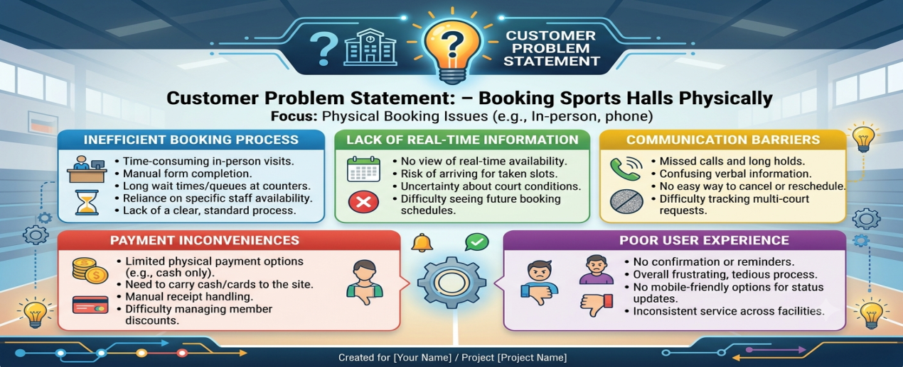
Problem Statement 1: Difficulty in Checking Hall Availability
Students currently have to visit the sports office or contact the sports coordinator to check whether a sports hall is available. Since there is no centralized online system, users often receive outdated information or discover that the hall has already been booked by someone else. This manual process consumes time, creates confusion, and discourages students from using the sports facilities efficiently.
Impact
- Wastage of time.
- Uncertainty about hall availability.
- Poor user experience.
- Reduced utilization of sports facilities.
Problem Statement 2: Double Booking and Manual Booking Errors
Manual booking methods using registers or verbal confirmations frequently result in duplicate bookings, scheduling conflicts, and human errors. Multiple users may reserve the same sports hall for the same time slot, leading to confusion, disputes, and inconvenience for both users and administrators.

Impact
- Double bookings , Scheduling conflicts.
- Increased administrative workload ,User dissatisfaction.
- Inefficient management of sports facilities.

